EXPERIMENT 15
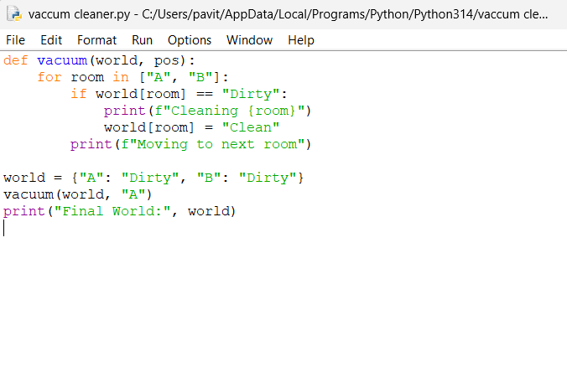
OUTPUT
